Lab 11: Simulation of Grid-Connected Module Integrated Parallel Inverters

Note: The requested data is often emphasized in the lab instructions with italicized text.

11.1 Objective
To develop complete average simulation model for a grid-connected module integrated parallel inverters consisting of DC/AC inverter and MPPT control. To perform medium-term simulations on grid-connected module integrated parallel inverters.

11.2 Simulation Software
The computers in EGR building are loaded with MATLAB/Simulink software. Make sure to download same version of MATLAB, Simulink and Simscape if you prefer to use your laptop for the lab sessions.

11.3 Simulink Model Development
Build a visually pleasing and clean model with less wiring complexity. Negative points apply for unpleasant models, though they are correct. After model completion, select all blocks (Ctrl + A), go to “Format” tab and change “Auto name” to “Name on” to display block names as shown in Figure.

Do not take screenshot of the model and results. Rather follow the approach below to copy the model and scope results to your lab report.

How to Copy Simulink Model to Report:
Open subsystem Maximize window Fit to View.
Format Screenshot Send Bitmap to Clipboard Paste in Word Document.

How to Copy Scope to Report:
Open scope Maximize window Scale X and Y axes Limits.
File Copy to Clipboard Paste in Word Document.

11.4 Designing Standalone PV Energy System
Read chapter 10 in textbook to understand the simulation of grid-connected module integrated parallel inverters.

Download Lab11.zip from the Canvas and extract the folder. Set the current directory of MATLAB to the Lab11 folder. Otherwise, you will get errors in running the simulations.

Open the MIPI.slx file. Do not run the simulation yet. The complete simulation model is shown in Fig. 11.1. The subsystems are empty, and they should be developed similarly to Figs. 11.2 to 11.8. Please note that the parameters in Simulink blocks are case sensitive. Change the Goto Tag visibility to “global”.
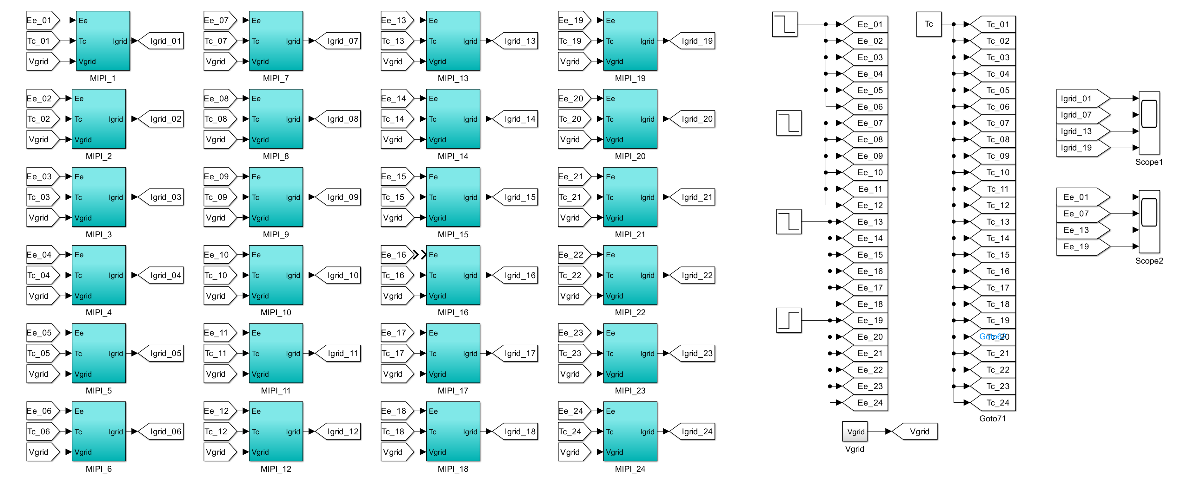
Fig. 11.1 Complete grid-connected PV system with module integrated parallel inverters.
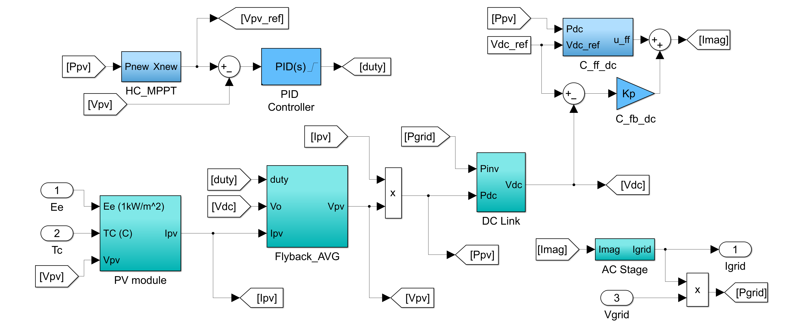
Fig. 11.2 Simulink model of MIPI_1 subsystem (set all goto tags to local).
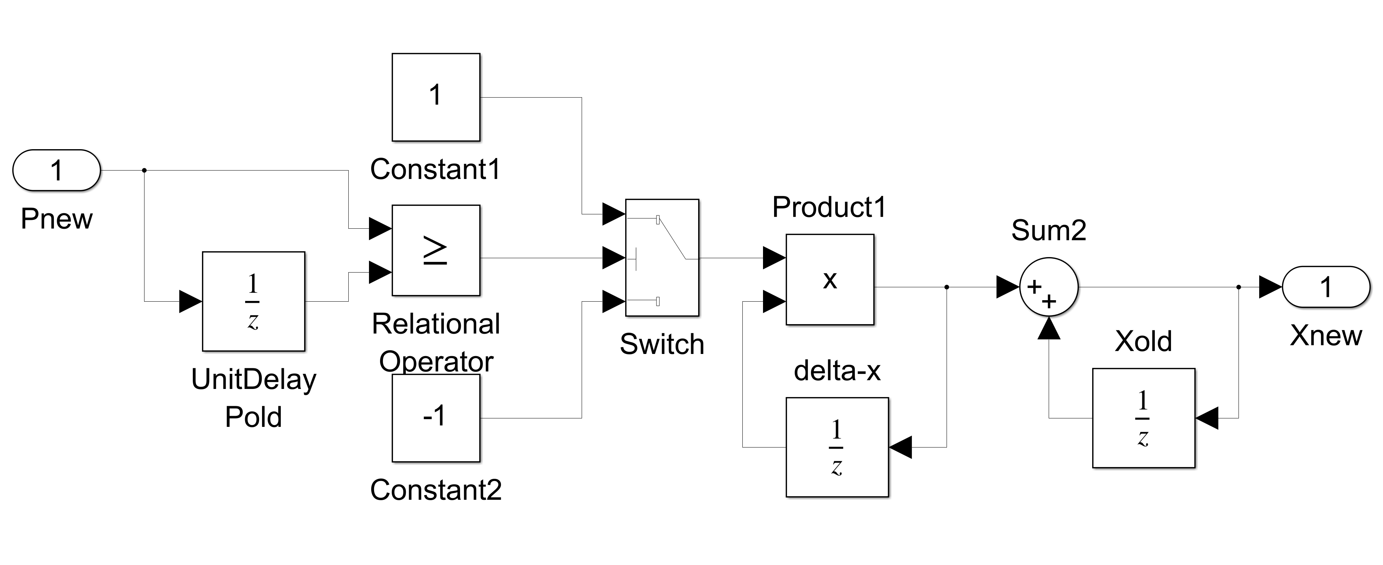
Fig. 11.3 Simulink model of HC_MPPT subsystem (same as in Lab 10).

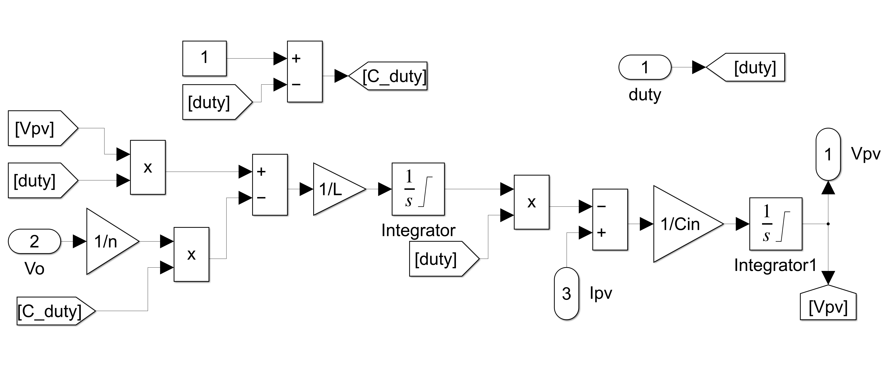
Fig. 11.4 Simulink model of Flyback_Avg subsystem.

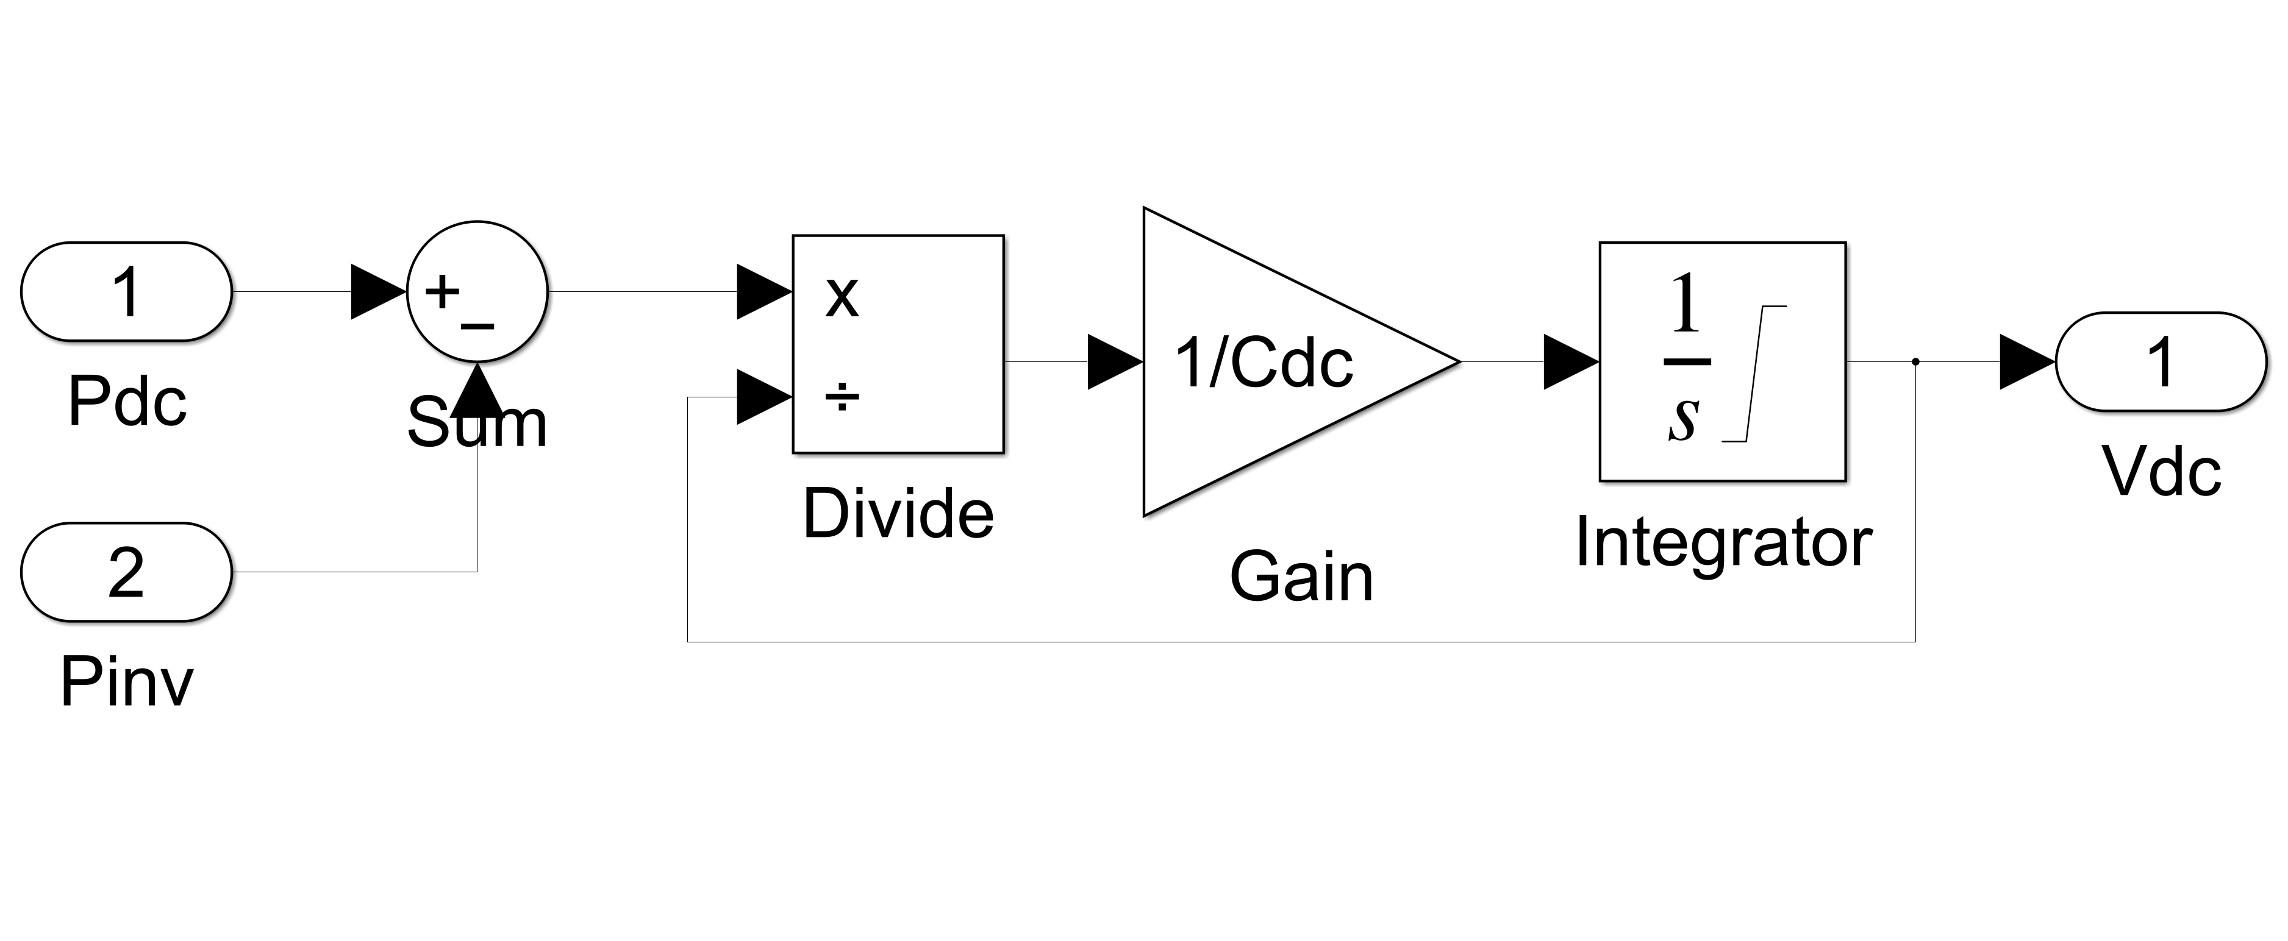
Fig. 11.5 Simulink model of DC Link subsystem (same as in Lab 10).

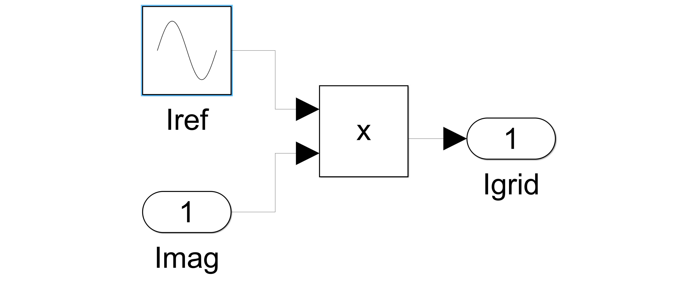
Fig. 11.6 Simulink model of AC stage subsystem (same as in Lab 10).

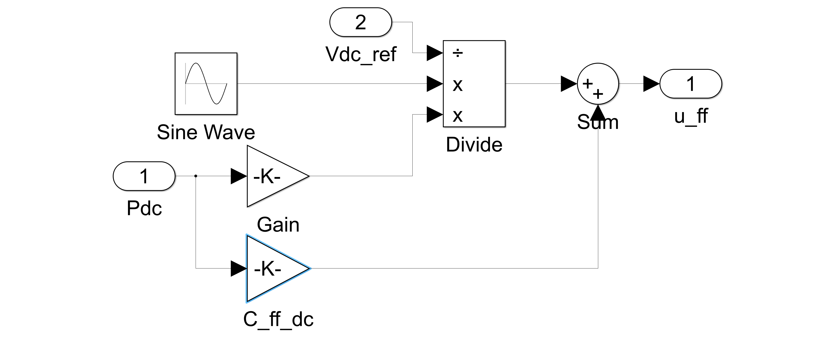
Fig. 11.7 Simulink model of C_ff_dc subsystem (same as in Lab 10).

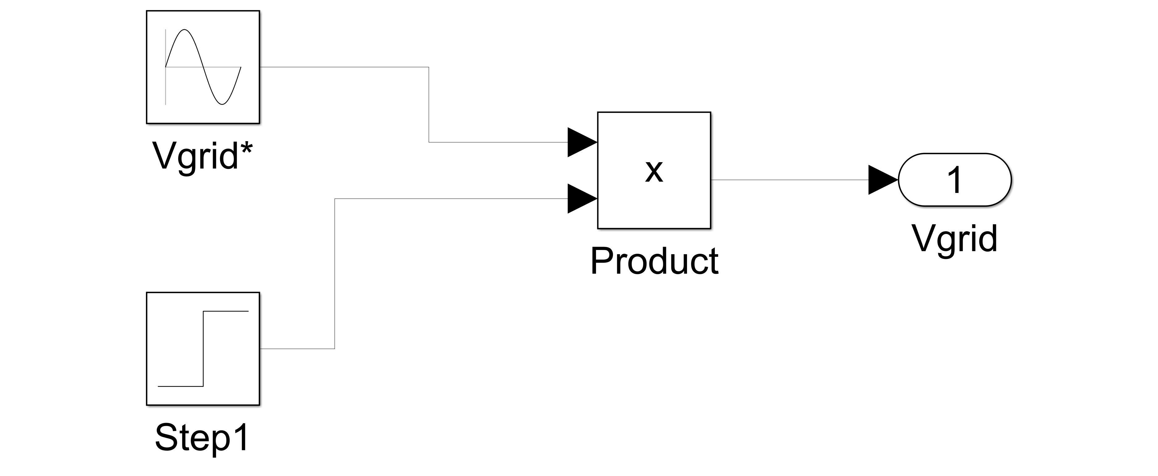
Fig. 11.8 Simulink model of Vgrid subsystem. This subsystem is on main page and NOT part of MIPI_1 subsystem. (same as in Lab 10).
Apply following parameters for the PID controller (Fig. 11.2):
- Time-domain: continuous-time
- Proportional (P): Kp0
- Integral (I): Ki0
- Filter coefficient (N): 1/Tau_d0
- Checkbox “enable zero-crossing”
- Checkbox “Limit output”. Upper limit: 0.9 and lower limit: 0.

Apply following parameters for the blocks in the HC_MPPT subsystem (Fig. 11.3):
- For all blocks, replace the sample time of -1 by 1/fmpp
- Initial condition for Pold (UnitDelay) block: 1e3
- Initial condition for Delta-x (UnitDelay) block: delta_x
- Initial condition for Xold (UnitDelay) block: x_init
- Threshold value for switch block: 0. Criteria for passing first input in switch block: u2 >= Threshold.

Apply following parameters for the blocks in the DC/DC Flyback_AVG subsystem (Fig. 11.4):
- Integrator block. Initial condition: 0, Upper saturation limit: inf, Lower saturation limit: 0
- Integrator 1 block. Initial condition: Voc_array, Upper saturation limit: inf, Lower saturation limit: 0

Apply following parameters for the blocks in the DC Link subsystem (Fig. 11.5):
- Integrator block. Initial condition: Vdc_ref, Upper saturation limit: inf, Lower saturation limit: 0

Apply following parameters for the blocks in the AC stage subsystem (Fig. 11.6):
- Iref (Sine Wave) block. Amplitude: 1, Bias: 0, Frequency (rad/s): 2*pi*Fb, Phase (rad): pi/2

Apply following parameters for the blocks in the C_ff_dc subsystem (Fig. 11.7):
- Sine Wave block. Amplitude: -1, Bias: 0, Frequency (rad/s): 2*pi*Fb*2, Phase (rad): 0
- Gain: Kp/Fb/2/pi/Cdc/2
- C_ff_dc gain: 2/Vmag

Apply following parameters for the blocks in the Vgrid subsystem (Fig. 11.1):
- Vgrid* (Sine Wave) block. Amplitude: 1, Bias: 0, Frequency (rad/s): 2*pi*Fb, Phase (rad): pi/2
- Step 1 block. Step time: Ttotal/6+5e-3, initial value: Vmag, Final value: Vmag

Once MPIPI_1 is done, copy and paste it 24 times. Change goto and from blocks connected to these subsystems. Open the Batch_Run_MIPI.m file and run the program to produce a figure similar to Module 10 part 2 slides. It takes few minutes to produce the plots, so please be patient. Maximize all the figures. The Batch_Run_MIPI.m file initializes the parameters, runs the simulation model and produces the results. In the figure, go to Edit tab and press Copy Figure and paste in your lab report. Explain each plot thoroughly. Results without explanation will receive half the points only. Keep all the models you have developed in your report.

Run “Plot_dynamic_resistance.m” file and copy two generated plots. Run “para_controller.m” file and note all results printed in MATLAB command window. Explain each line printed in command window. Explain how Kp, Ki and N are calculated for PID controller?

11.5 Instructions for Lab Report
Detailed instructions for the lab report preparation are available on Canvas. Each team member should identify his/her portion of the writing in both the pre-lab (if exists) and post-lab reports.

The report should include the following results and analysis:
- 1 figure along with explanation for grid-connected PV system.
- Screenshot of scope 1 and scope 2 plots.
- 2 figures along with explanation for figures generated from Plot_dynamic_resistance.m file
- Screenshot of simulation models you have developed

